**CSC 1101 – Problem Solving and Programming Laboratory**

**Lab 7 – Omar Faruk**

**25 points – Due September 29, end of lab**

**a)** Save this document with your name and the lab assignment number somewhere in the file name.

**b)** Type/paste your answers into the document.

**c)** Submit this document to the Canvas item where you downloaded this document.

**Grade Point Average (GPA) Calculator:**

As a programmer, you are hired to calculate the GPA of an undergrad student in Computer Science Department using a C++ console application. Let, a student takes three (courses) in Fall 2020. Each course can have different credit hours. At the end of the semester a student may get different grades for each course. The formula for calculating the GPA is (i=1 to 3 for considering 3 courses):

$GPA=\frac{\sum_{i=1 }^{ 3}{({course}_{credit[i]}*course_grade[i])}}{total_course_credi{ts}_{of}three_courses}$……………………(1)

The derivation of equation 1 is

GPA= (course_credit1*grade1+course_credit1*grade2+course_credit3*grade3)/total_credit_hours;

Where total_credit_hours= course_credit1+ course_credit2+ course_credit3;

Now, write a C++ console where you need to do the followings:

1. Add header comments
2. Declare two constants COLMT
3. Declare a string variable std_name. Prompt the user to put the student name.
4. Declare three string variables for course names (course1, course2, course3). Prompt the user to take three course names.
5. Declare three double variables (credit_course1, credit_course2, credit_course3) for each course credit. Prompt the user to put the credit hours for corresponding courses.
6. Declare three double variables (grade_course1, grade_course2, grade_course3) for each course grades. Prompt the user to put the grades for corresponding courses.
7. Calculate the GPA by using formula and print it. Print the GPA within 2 decimal places using setprecision().
8. Use setw(), left, and right alignment and do it according to the given input/output.
9. Run the program two times. First, put the given value in the sample input. Second, change the values and run it.

Sample Input/Output

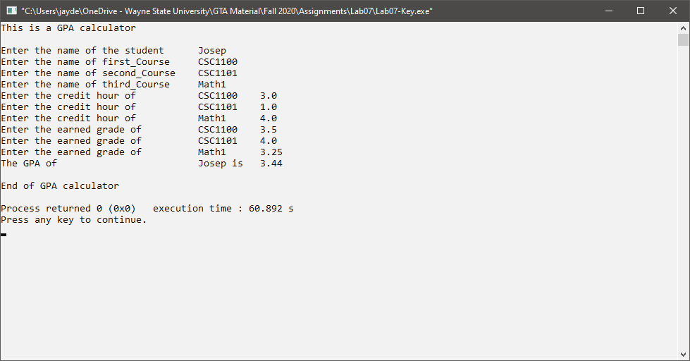

*[your program code here]\**

//==========================================================

//

// Title: GPA Calculator

// Course: CSC 1101

// Lab Number: Lab 07

// Author: Omar Faruk

// Date: 09/29/2020

// Description:

// Creatinga GPA calculator

// using table formatting, calculations, and variables.

//

//==========================================================

#include <cstdlib> // For several general-purpose functions

#include <fstream> // For file handling

#include <iomanip> // For formatted output

#include <iostream> // For cin, cout, and system

#include <string> // For string data type

using namespace std; // So "std::cout" may be abbreviated to "cout"

int main()

//==========================================================

//

// Title: GPA Calculator

// Course: CSC 1101

// Lab Number: Lab 07

// Author: Omar Faruk

// Date: 09/29/2020

// Description:

// Creatinga GPA calculator

// using table formatting, calculations, and variables.

//

//==========================================================

#include <cstdlib> // For several general-purpose functions

#include <fstream> // For file handling

#include <iomanip> // For formatted output

#include <iostream> // For cin, cout, and system

#include <string> // For string data type

using namespace std; // So "std::cout" may be abbreviated to "cout"

int main()

{

// Setting decimal points

cout << fixed << setprecision(2);

//Constants

const int COLMT1 = 40;

const int COLMT2 = 10;

// Declare variables

string std_name;

string course1;

string course2;

string course3;

double course_credit1;

double course_credit2;

double course_credit3;

double grade_course1;

double grade_course2;

double grade_course3;

double gpa;

//User Inputs

//Student Name

cout << "Enter the name of the student: " << endl;

cin >> std_name;

//Course Name

cout << "Enter the name of first course: " << endl;

cin >> course1;

cout << "Enter the name of second course: " << endl;

cin >> course2;

cout << "Enter the name of third course: " << endl;

cin >> course3;

//Course credit

cout << "Enter the credit hour of " << course1 << endl;

cin >> course_credit1;

cout << "Enter the credit hour of " << course2 << endl;

cin >> course_credit2;

cout << "Enter the credit hour of " << course3 << endl;

cin >> course_credit3;

//Course Grade

cout << "Enter the earned grade of " << course1 << endl;

cin >> grade_course1;

cout << "Enter the earned grade of " << course2 << endl;

cin >> grade_course2;

cout << "Enter the earned grade of " << course3 << endl;

cin >> grade_course3;

//Calculation

double total_credit_hours = (course_credit1 + course_credit2 + course_credit3);

gpa = (course_credit1 * grade_course1 + course_credit2 * grade_course2 + course_credit3 * grade_course3) / total_credit_hours;

// Show application header

cout << "Welcome to GPA calculator!" << endl;

cout << "--------------------------" << endl << endl;

cout << setw(COLMT1) << left << "Enter the name of the student: ";

cout << setw(COLMT2) << right << std_name << endl;

cout << setw(COLMT1) << left << "Enter the name of the first course: ";

cout << setw(COLMT2) << right << course1 << endl;

cout << setw(COLMT1) << left << "Enter the name of the second course: ";

cout << setw(COLMT2) << right << course2 << endl;

cout << setw(COLMT1) << left << "Enter the name of the third course: ";

cout << setw(COLMT2) << right << course3 << endl;

cout << setw(COLMT1) << left << "Enter the credit hour of: ";

cout << setw(COLMT2) << right << course1;

cout << setw(COLMT2) << left << "\t" << course_credit1 << endl;

cout << setw(COLMT1) << left << "Enter the credit hour of: ";

cout << setw(COLMT2) << right << course2;

cout << setw(COLMT2) << left << "\t" << course_credit2 << endl;

cout << setw(COLMT1) << left << "Enter the credit hour of: ";

cout << setw(COLMT2) << right << course3;

cout << setw(COLMT2) << left << "\t" << course_credit3 << endl;

cout << setw(COLMT1) << left << "Enter the earned grade of: ";

cout << setw(COLMT2) << right << course1;

cout << setw(COLMT2) << left << "\t" << grade_course1 << endl;

cout << setw(COLMT1) << left << "Enter the earned grade of: ";

cout << setw(COLMT2) << right << course2;

cout << setw(COLMT2) << left << "\t" << grade_course2 << endl;

cout << setw(COLMT1) << left << "Enter the earned grade of: ";

cout << setw(COLMT2) << right << course3;

cout << setw(COLMT2) << left << "\t" << grade_course3 << endl;

cout << setw(COLMT1) << left << "The GPA of ";

cout << setw(COLMT2) << right << std_name << " is";

cout << setw(COLMT2) << left << " " << gpa << endl;

//App Close

cout << "\nEnd of GPA calculator" << endl;

}

*[your program output here]\*\**

